**Linear Regression Using Sci-kit Learn :**

**(1) Import data :**

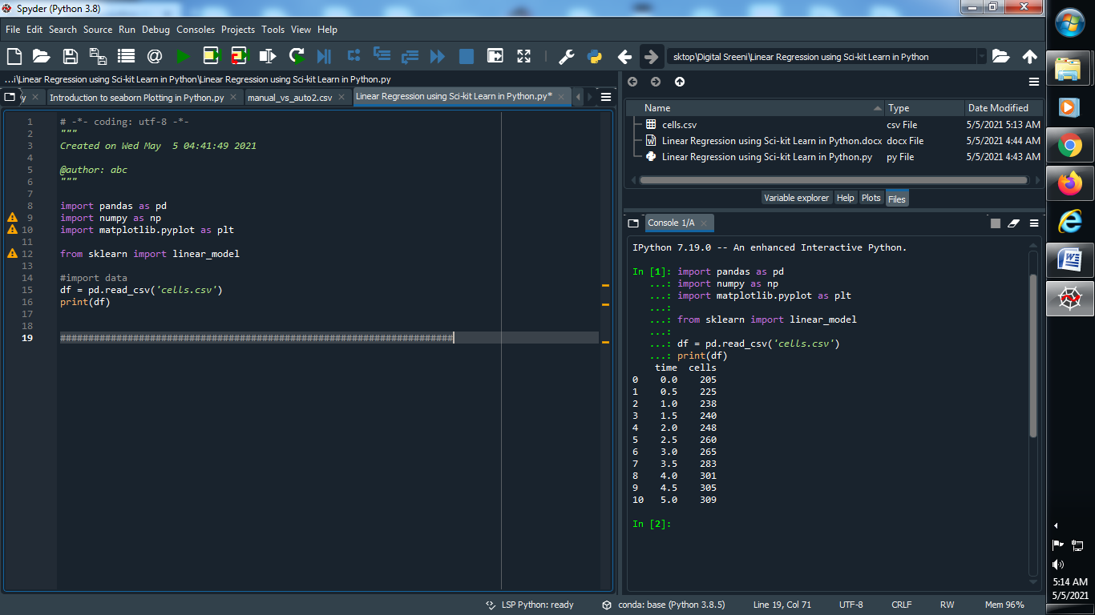

**Output :**



**(2) Plot the data using scatter :**

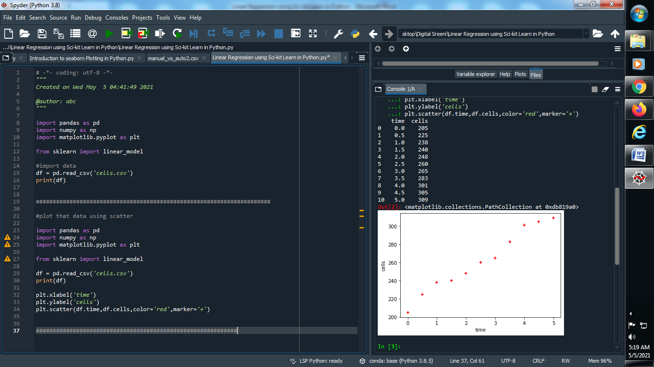

**Output :**



**(3) Predict the score means how well data is predicted :**

**Note : If score is 1 or nearly 1 it means our data is predicted perfectly**

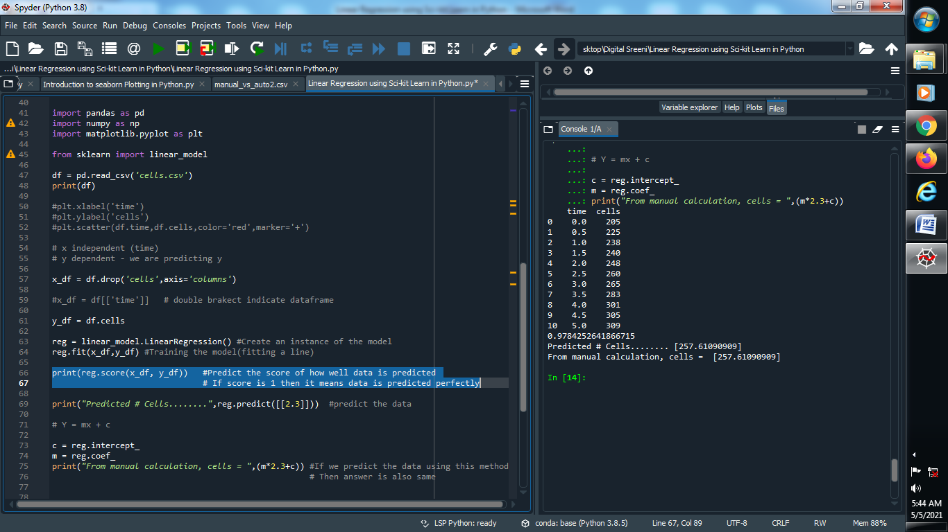

**Output :**



**(4) Predict the particular given data :**

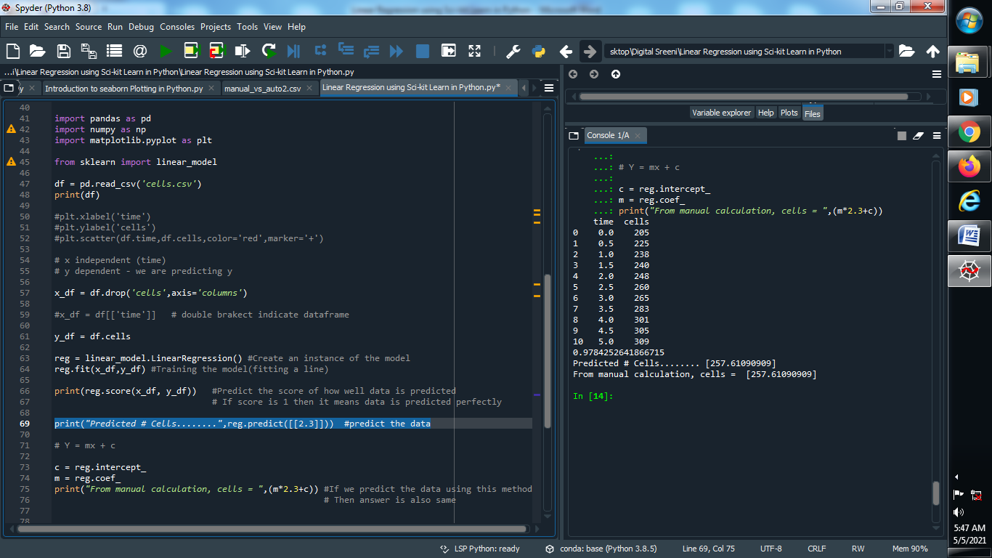

**Output :**



**(5) Predict the particular data using Y = MX + C METHOD :**

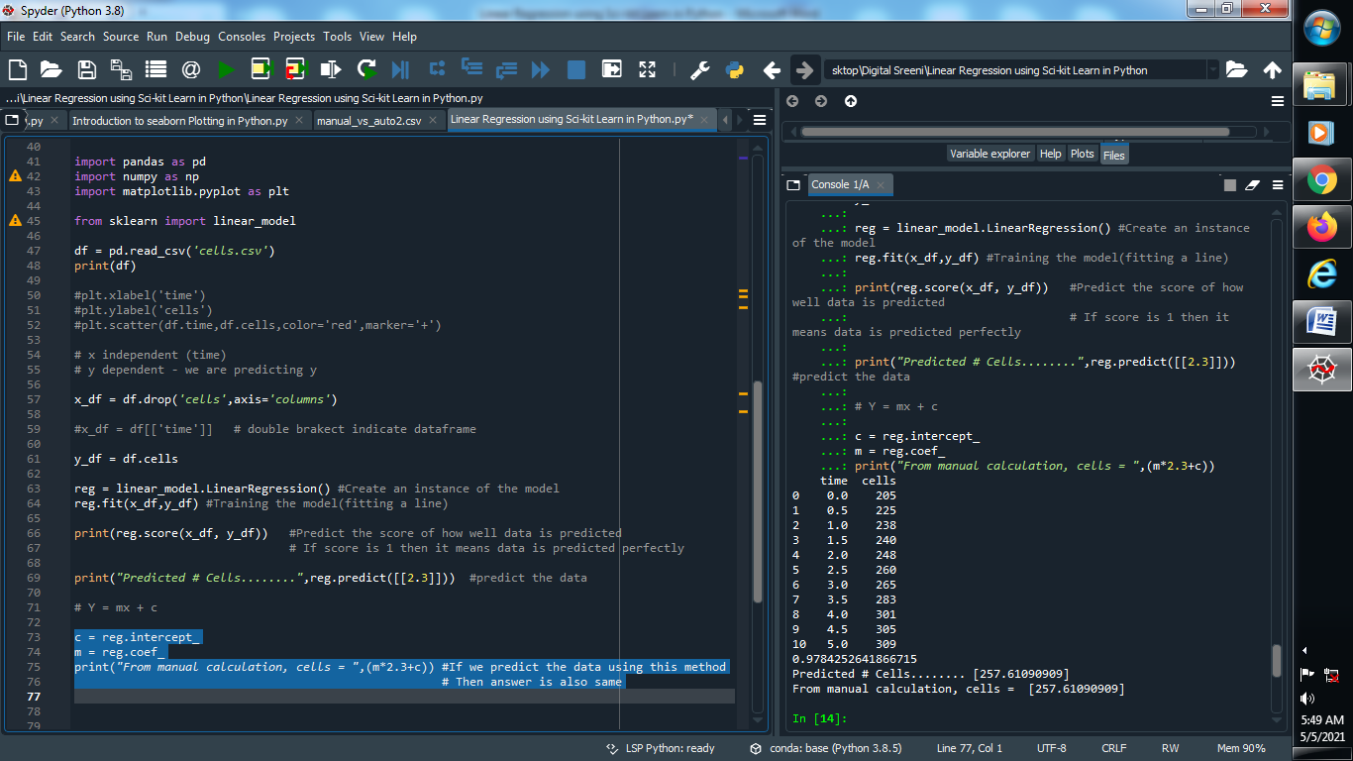

**Output :**



**(6) Predict one value of x with respect to y :**

**Step 1 : Reading our new file dataset**

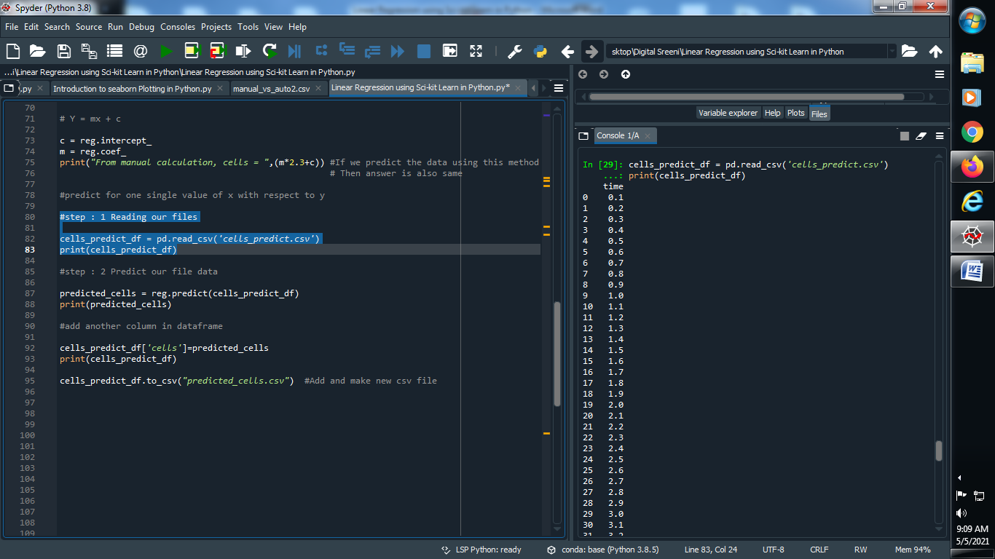

**Output :**



**Step 2 : Predict our dataset :**

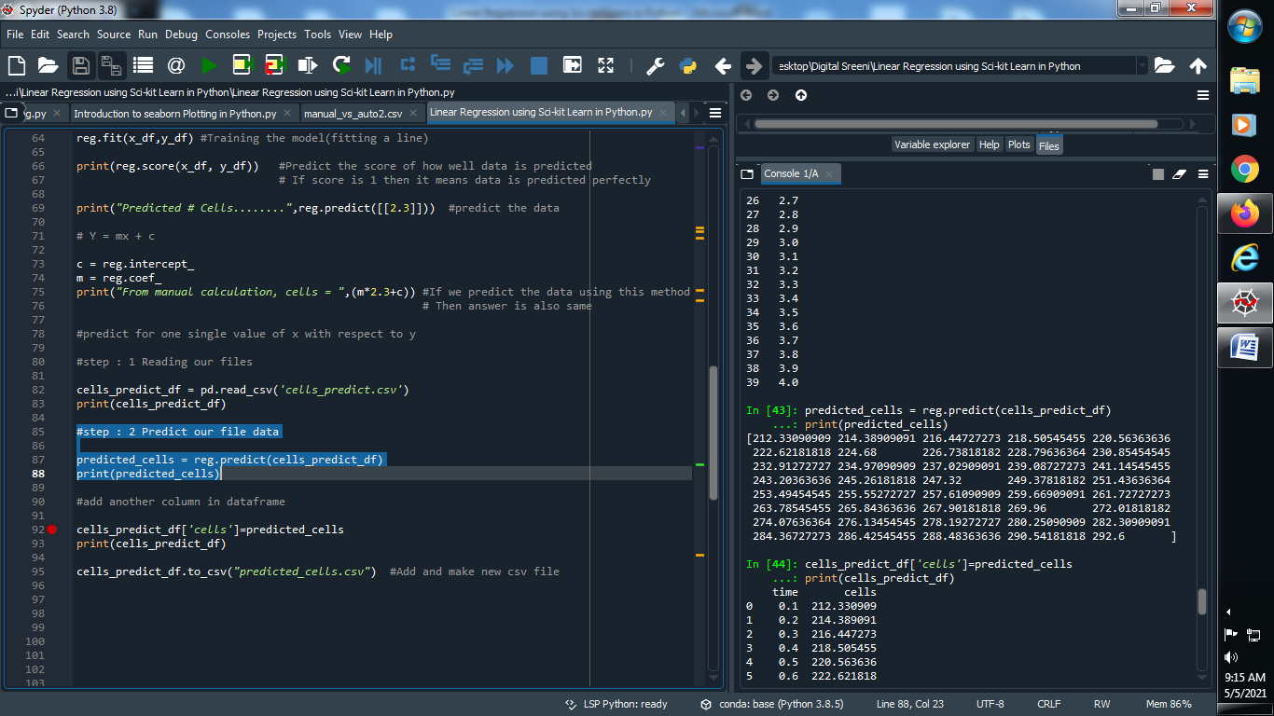

**Output :**



**Step : 3 Add another column in dataset :**

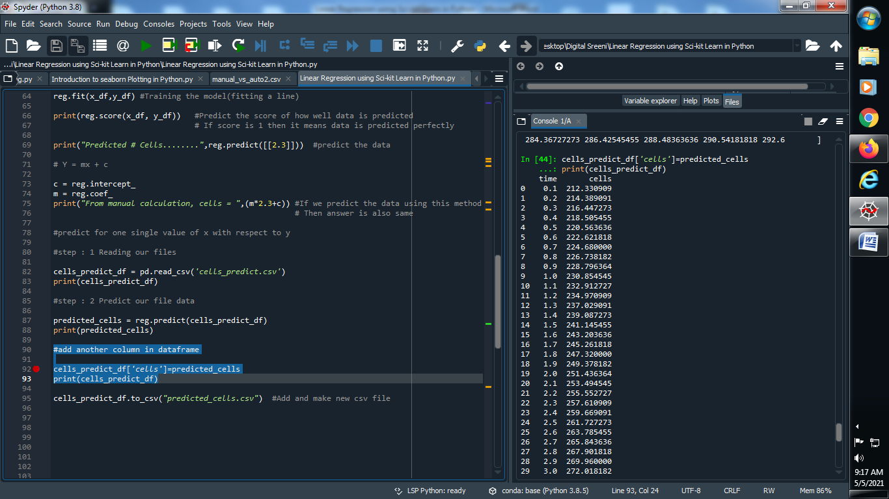

**Output :**



**Step : 4 Update and modify that csv file :**

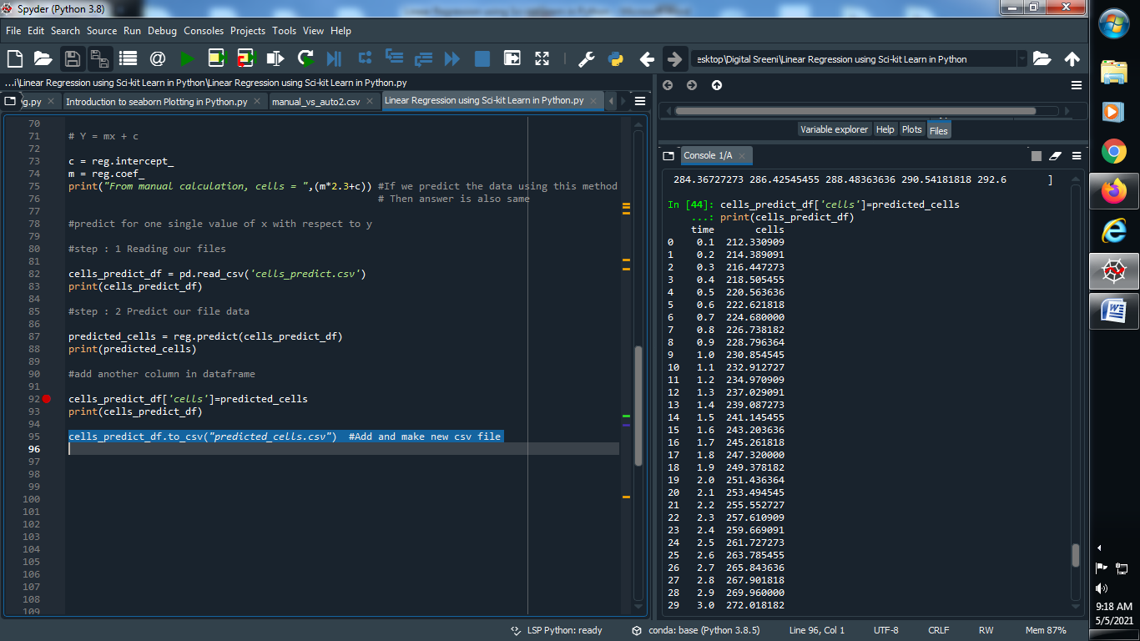

**Output :**

